First Assessment, Company Lockers Pvt. Ltd. Project objective:

As a Full Stack Developer, complete the features of the application by planning the development in terms of sprints and then push the source code to the GitHub repository. As this is a prototyped application, the user interaction will be via a command line.

**Sprints:**

**Sprint number: 3 (Timebox 1 week 1 sprint) Product story : Collect the requirement such that the user story is: Independent Negotiable Valuable Estimable Small Testable.**

**In each sprint create a reasonable product. Design product paradigm, design modules, integrate modules and test.**

**Sprint planning with Product Owner, Scrum Master and Development Team. Daily Scrum to discuss and evaluate the progress.**

**Sprint Review: Elicit feedback and foster collaborations. End of each week. At the end, the product is presented to the product owner for acceptance or refusa**l

**Sprint Retrospective : Meeting to plan and decide on enhancing and integrating in the next project.**

Background of the problem statement:

Company Lockers Pvt. Ltd. hired you as a Full Stack Developer. They aim to digitize their products and chose LockedMe.com as their first project to start with. You’re asked to develop a prototype of the application. The prototype of the application will be then presented to the relevant stakeholders for the budget approval. Your manager has set up a meeting where you’re asked to present the following in the next 15 working days (3 weeks):

Specification document - Product’s capabilities, appearance, and user interactions

Number and duration of sprints required

Setting up Git and GitHub account to store and track your enhancements of the prototype

Java concepts being used in the project

Data Structures where sorting and searching techniques are used.

Generic features and three operations:

Retrieving the file names in an ascending order

Business-level operations:

Option to add a user specified file to the application

Option to delete a user specified file from the application

Option to search a user specified file from the application

Navigation option to close the current execution context and return to the main context

Option to close the application

The goal of the company is to deliver a high-end quality product as early as possible.

**The flow and features of the application: ** Plan more than two sprints to complete the application

Document the flow of the application and prepare a flow chart

[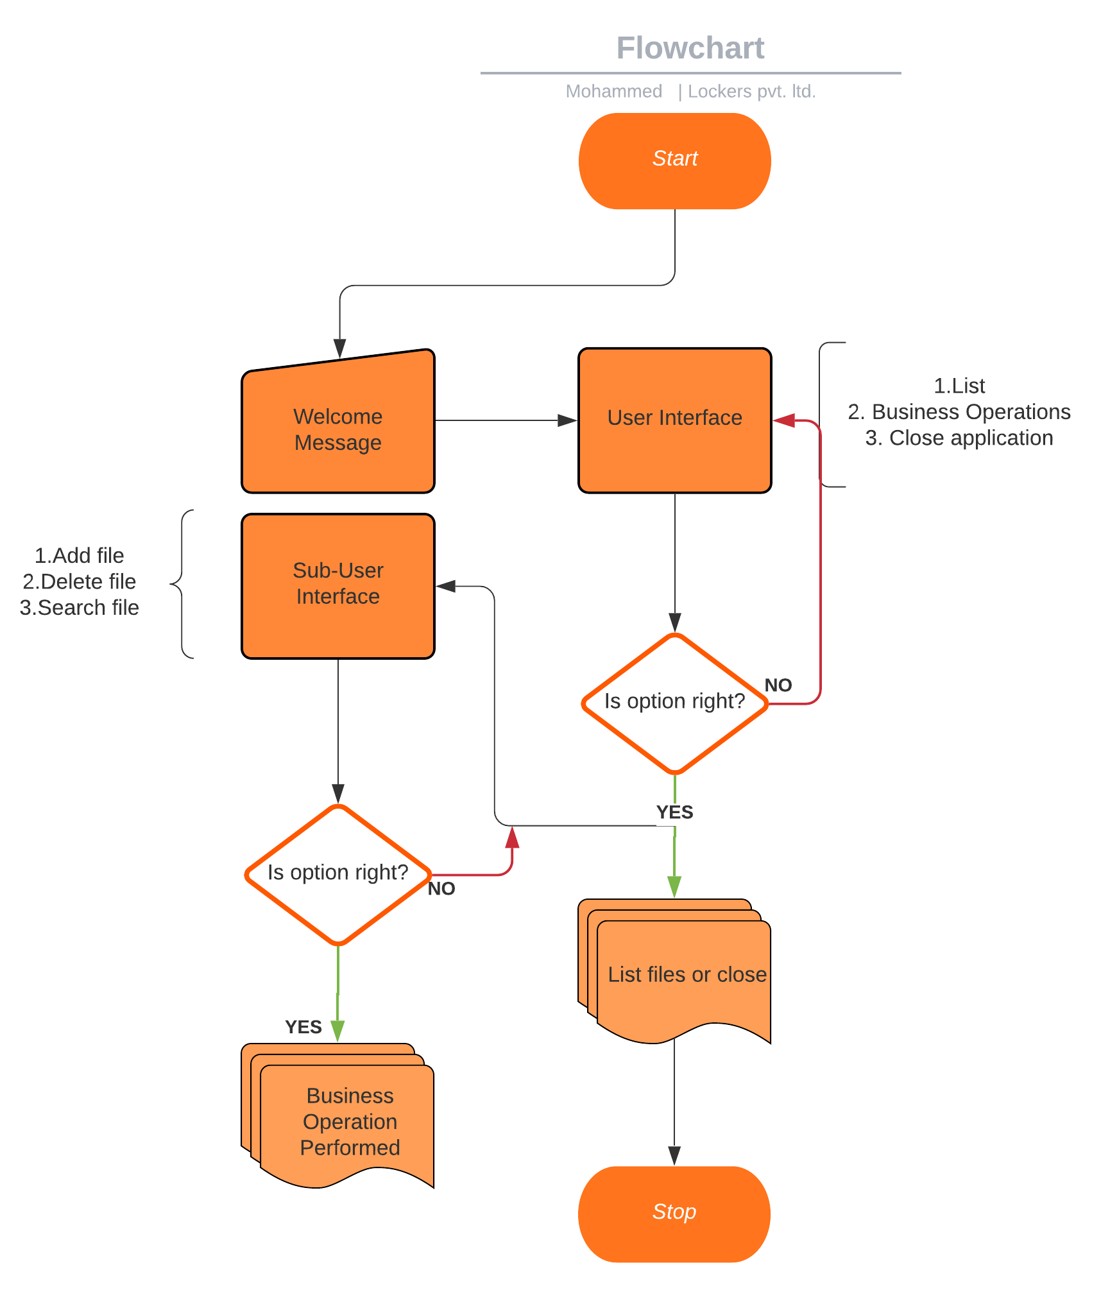](https://user-images.githubusercontent.com/95872805/147804782-b9121648-4234-41f2-8e8b-3bc00362a989.png)

List the core concepts and algorithms being used to complete this application

Code to display the welcome screen. It should display:

Application name and the developer details

The details of the user interface such as options displaying the user interaction information

Features to accept the user input to select one of the options listed

The first option should return the current file names in ascending order. The root directory can be either empty or contain few files or folders in it

The second option should return the details of the user interface such as options displaying the following:

Add a file to the existing directory list

You can ignore the case sensitivity of the file names

Delete a user specified file from the existing directory list

You can add the case sensitivity on the file name in order to ensure that the right file is deleted from the directory list

Return a message if FNF (File not found)

Search a user specified file from the main directory

You can add the case sensitivity on the file name to retrieve the correct file

Display the result upon successful operation

Display the result upon unsuccessful operation

Option to navigate back to the main context

There should be a third option to close the application

Implement the appropriate concepts such as exceptions, collections, and sorting techniques for source code optimization and increased performance

**Defining the USPs (Unique Selling Points)

**Usage of UI/UX interface Regular expression for validation Binary search to search for a file based on list number Use distributed modules. Stored procedures to reuse the code Connect with database to implement on multiple devices**\*\*

You must use the following:

Eclipse/IntelliJ: An IDE to code for the application

Java: A programming language to develop the prototype

Git: To connect and push files from the local system to GitHub

GitHub: To store the application code and track its versions

Scrum: An efficient agile framework to deliver the product incrementally

Search and Sort techniques: Data structures used for the project

Specification document: Any open-source document or Google Docs

**List of core concepts Array lists Collections Exception handling Bubble sort Printwriter Array FileIO operations File handlers/functions**